Optics Magic at Home with Judy & Nancy
TWISTING LIGHT

HOW DO POLARIZED SUNGLASSES WORK? CAN YOU USE POLARIZED LIGHT TO MAKE COLORFUL ART OUT OF clear TRANSPARENT MATERIAL?
This STEAM lesson includes both science and art activities.

MATERIALS
Activity 1 – Bright and Dark
- A polarizing filter (polarizer). This can be polarized sunglasses or a piece of polarizing film (available from science supply houses), or “3D” glasses with polarizing plastic
- An LCD screen such as a laptop, tablet or television screen
Activity 2 – What is Polarized Light?
- The polarizing filter from Activity 1
Activity 3 – Colors from Polarization
- The polarizing filter from Activity 1
- Cellophane tape
- (Optional) A square of transparency film or other thin plastic to protect the monitor and polarizer from adhesive damage.

Where to find materials: Polarized sunglasses can sometimes be found in a dollar store. You can carefully remove the lenses to have two polarizers to work with. Sometimes sunglasses are labeled polarized when they are not. To check, take two pair of sunglasses and rotate the lens of one in front of a lens of the other. The light coming through the pair of lenses should dim as you rotate. Some online sellers advertise polarized sunglasses for a few dollars. Be sure to read the comments to see if they are really polarized; if they aren't people usually complain about it.

Educational Innovations sells small sheets of polarizing materials; for larger quantities for a class see the shop at polarization.com which sells sheet polarizer.. Some 3D glasses used in theaters will work for this experiment. Be sure they use linear polarizers, not circular polarizers. (Sunglasses will be linear polarizers). You can buy 3D glasses in bulk at Rainbow Symphony Store. You can also use a polarizing filter from a camera but those are expensive so be careful!

Transparent packing tape works well in this experiment, but try other types of cellophane and plastic. Austine Wood Comarow, an artist who works with polarized light (see Resources), said she carries polarizers with her when she shops so she can test various packaging materials for their color-producing properties. Experiment!

PARENT AND TEACHER NOTES:
The lesson begins by observing polarization before explaining how it works.

ACTIVITY 1 – BRIGHT AND DARK
Hold a lens of the sunglasses in front of one eye and look through it at a laptop or tablet screen or a TV with a liquid crystal display (LCD). Now slowly rotate the lens (or if you’re wearing the sunglasses, tip your head from side to side, one shoulder to the other). What do you see? If you rotate the lens in front of your eye, how many times does the light dim in one 360º rotation?

Light from an LCD screen is polarized. The light passing through the sunglass lens should alternately dim and brighten twice as the polarizer is rotated in front of it through one complete turn (360º).

ACTIVITY 2 – WHAT IS POLARIZED LIGHT?
Light reflecting from glass windows, a waxed ﬂoor or the surface of water is also partly polarized and should show some dimming and brightening as the polarizer is rotated. If it’s a sunny day, go outside and look at the blue sky, again rotating the polarizer. Look at the sky in diﬀerent directions. DO NOT LOOK AT THE SUN! The blue sky is polarized in diﬀerent directions at diﬀerent times of the day. Bees can sense this polarization and use it to navigate.

So what is polarized light? Like all analogies, what follows is not an exact description of how light behaves but it is an age-appropriate explanation for a 10-12 year old. So-called natural light, like from the sun or a light bulb, can be modeled by waves that vibrate in all directions as they travel forward. Imagine shaking a rope tied to a tree; you can shake the end up and down, left and right or at an arbitrary angle.

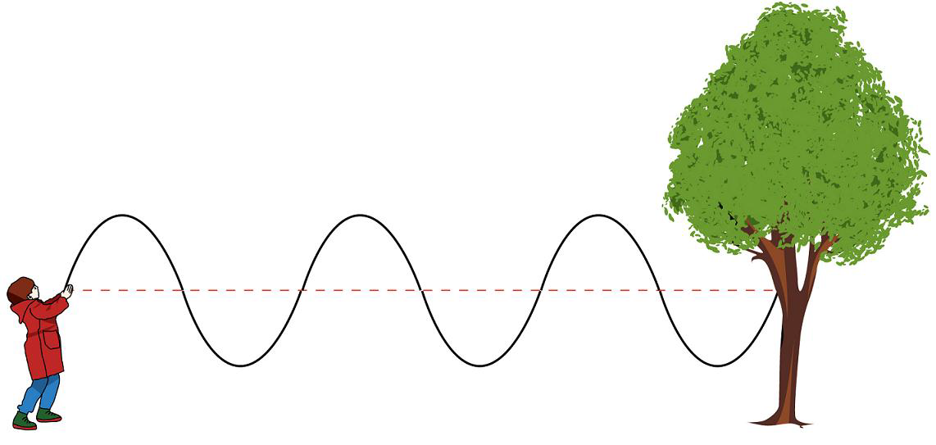

Figure 1 – Shaking a rope tied to a tree to make waves. (Source: CK Foundation via Wikimedia Commons)

Now imagine you are shaking the rope as it goes through a picket fence. Up and down waves will pass, side-to-side waves will not. It’s a bit more complicated for light; waves at an angle “partially” pass through but that is not important for the qualitative activities of this lesson. (See Figure 2.)
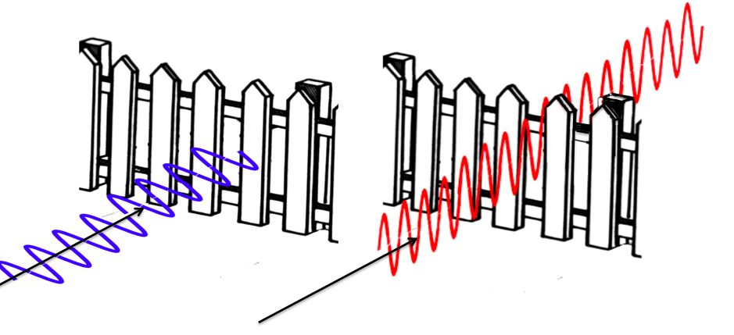
Figure 2 – Vertical waves can pass through the slats of a picket fence, horizontal waves are blocked.

You can make rope waves as an additional activity. A rope or heavy string can be shaken up and down or to make waves. For the brave, try tying one end of the rope to a reciprocating saw or an electric knife – anything that vibrates quickly up and down. Pass the rope through the wires of a cooling rack or an oven rack to illustrate polarization, turning the rack to pass or block the vibrating rope waves.

Application: Although sunlight is not polarized, reflections of the sun from snow or water are polarized, that is, the light waves vibrate in one direction. The polarizing ﬁlters (lenses) in sunglasses block the reﬂected light. The glare from sunlight reﬂected from a lake is polarized horizontally (waves parallel to the water surface). The polarizers in the glasses must be in the vertical direction to block horizontal waves – or they won’t work.

ACTIVITY 3 – COLORS FROM POLARIZATION!
Polarization leads to some pretty amazing results, like the “magic box” in the video mentioned in the References. In this activity it’s used to create colored art from clear transparent materials. It’s easiest to see if you make the laptop or table screen mostly white, like a blank document.

Take a few cm of clear transparent tape and crumble it. Place it gently on the screen and look at it through the polarized sunglasses. Rotate the glasses (or turn your head). Do the colors change?

The colors come from the interaction of polarized light with the cellophane or plastic. Tape is stretched when it’s manufactured which gives it different properties in the stretched and non-stretched directions. Different types of plastic are also stretched or placed under some stress that makes them also work well. Experiment!

How does this work? When polarized light from the laptop screen passes through the tape, the direction of the light wave’s vibration is changed (rotated). The amount of rotation depends on the wavelength (color) of the light. Thus, diﬀerent colors are seen as the polarizing lens of the sunglasses rotates and allows them to pass. The amount of rotation of the waves depends on the thickness of the tape so adding more layers changes the color you see. If you are patient you can try adding layers to make different colors.

Tape pieces

Polarized light from the Pieces of tape rotate the Rotating the polarizing lens
screen. The arrow means direction of vibration. Each allows the different colors to
the waves are vibrating color now vibrates in a pass
up and down. different direction.

Figure 3 – Different wavelengths of light are rotated by different amounts as the light passes through cellophane or similar material.

What is labeled “cellophane” in stores may be plastic ﬁlm that will not work well in this experiment. (True cellophane is made from cellulose.) Some of the best colors come from clear packing tape, the clear wrappers on some supermarket vegetables, and the clear sleeves ﬂorists use for ﬂoral stems. Even though the directions specify cellophane, some plastics will work as well. Tape is easy to use but hard to cut into shapes. If you use cellophane or plastic (tested to make sure it produces colors), use a bit of glue stick to hold it to the transparency ﬁlm. Rubber cement works even better but is not considered appropriate for children. They should be closely supervised.

Instead of an LCD screen, this activity can also be done with two pieces of polarizing film. The “sandwich” is polarizer, cellophane, polarizer. Some backlight is needed so you need to hold the “sandwich” up to a light or window and look into the top polarizer through all the three layers. Rotate the top polarizer to change colors.

APPLICATIONS
Materials with different optical properties in different directions are called birefringent. When plastic or glass is mechanically stressed (a force is applied) it can become birefringent. In some cases, it returns to its normal state when the stress is released. If the stress is applied when the piece is heated during manufacture, it can remain "frozen in" when the piece cools. This technique can be used to see if there is any stress remaining when glass is manufactured especially for precision uses like gas laser tubes. Residual stress in glass can result in it shattering when tapped or bumped.

You can see stress birefringence in transparent plastics like protractors or clear plastic flatware, also eyeglass lenses. Put the piece to be examined between two polarizers and rotate the top one to look for color lines or areas. Try twisting the plastic – do the lines change?

Real (expensive!) art is produced by this technique. Austine Wood Comarow creates Polarized Light Art, (she calls it Polage® art, a term coined from polarized light collage). Her work sells for thousands of dollars, and some pieces are wall-sized collages on display in museums. See http://www.austine.com for videos and examples of her work.

RESOURCES
The Dumpster Optics Power Point slides in English and in Spanish for classroom use for this lesson are here: https://www.pblprojects.org/teaching-and-learning-optics-with-inexpensive-materials/

Three videos of the lesson's activities are available on the PBL Projects YouTube channel, including one showing the construction of a "magic polarized light box":
- Exploring Polarization
- Polarized Light Art
- The Magic Box

This is an older web site with interesting information on polarization in nature https://www.polarization.com/index-net/

