Optics Magic at Home with Judy & Nancy
THE COLORS OF LIGHT
WHAT ARE THE COLORS THAT MAKE UP WHITE LIGHT? IS EVERY LIGHT THE SAME?
In this lesson you will learn how to make a rainbow from an old CD-R and then make a spectroscope to look at the colors emitted by different light sources.
MATERIALS
Activity – 1 Make a Rainbow
- An old recordable CD (CD-R) that you don’t need any more. (Save the case for an upcoming webinar.)
- An index card or similar size piece of thin cardboard or black construction paper
- Tape
- Scissors
- A flashlight with a single bulb or an LED keychain with a single bulb.
Activity 2 – Make a spectroscope
- The piece of CD from Activity 1
- A cardboard tube like a toilet paper tube or a paper towel tube cut in half
- A square of aluminum foil or a circle of black construction paper to go over one end of the tube
- A sharp pencil or a ballpoint pen thick needle (like a tapestry needle) to poke a hole
- Tape or glue
Activity 3 – The Colors of Lights
- A variety of light sources–including phone screens, laptop monitors and TVs, colored light strings. Try to find some lights that are visually similar colors like incandescent, white LED and fluorescent bulbs, or incandescent and LED bulbs of the same color. Two strings of Christmas lights, one incandescent and one LED, make an interesting comparison
WHERE TO FIND MATERIALS
- The CD must be the kind you record yourself so you can remove the label; commercially made CDs have labels that are difficult to remove. If you want to purchase diffraction gratings, they are available from many science supply stores (such as Educational Innovations, www.teachersource.com) and can be purchased in bulk (minimum order of 50) from Rainbow Symphony Store (www.rainbowsymphonystore.com). Be sure to get "linear" gratings, not two- dimensional gratings.
- LED Finger lights are good for all kinds of optics experiments including this one. They come in several colors and can be found in dollar stores and online.

PARENT AND TEACHER NOTES:
In this lesson, children will create a spectroscope and use it to do elementary spectroscopy by breaking light into its component colors, or spectrum (plural spectra). Spectroscopy is important in many areas of science and technology, for example, for identifying plant diseases (looking at the spectrum of light reflected from leaves), studying the universe (the spectrum of light given off by stars, galaxies, and absorbed by dust clouds), matching paint colors, identifying unknown substances at a crime scene and more.

BREAKING LIGHT INTO A SPECTRUM OF COLORS: White light is composed of all the colors of the rainbow- red, orange, yellow, green, blue, (indigo, if included) and violet - ROY G B(I)V. A light source's spectrum depends on how the light is produced. It is not possible to tell with the naked eye what colors are in the spectrum of a given light source, for example, all the colors on an LED screen are made with red, blue and green LEDs. Instruments used to study the color makeup of a light source can be very complex but there are some features common to all:
- A device that spreads the light out into its “rainbow” spectrum of colors
- Something to block out stray light from the surroundings
- A thin entrance slit that lets in a sample of the light being studied
- A sensor to detect the spectrum

You probably know that you can spread white light into a rainbow spectrum using a prism. But prisms are difficult to line up correctly. A diffraction grating (or just “grating”) is a series of very closely spaced grooves that bend light and cause it to spread out into its spectral colors. The CD used in this lesson is a kind of grating. Before the label is removed, the CD reflects white light as a rainbow (reflective grating) and after the label is removed light passes through the plastic and is spread into a spectrum (transmission grating).

The simple spectroscope in this lesson uses a cardboard tube to exclude room light and a slit (or hole) cut in a piece of aluminum foil to allow only a thin line (or spot) of light to enter and be examined. Your eye is the sensor! A more sophisticated spectrometer would use a sensor such as a camera to detect light and electronics to measure and display the spectrum.

A note on the color indigo: Some sources place the color "indigo" between blue and violet in the rainbow spectrum. Isaac Newton apparently wanted seven spectral colors to match the seven notes of a musical scale. What he called indigo is closer to what we would now call blue, and blue was a blue-green. In any case, indigo is sometimes omitted especially in modern writings, although BIV certainly makes an easier to pronounce acronym than BV. (See the Resources if you’d like to know more.)

ACTIVITY 1 – MAKE A RAINBOW
- First, look at the shiny side of the CD. You can easily see rainbow reflections from the fine grooves in the plastic.
- The CD label must be removed to let light pass through. An adult should cut the CD into four equal quarters using sturdy scissors. Be careful of sharp edges! Try to round the edges if you can. If you use a purchased diffraction grating, be sure to handle it by the edges to avoid finger smudges.
- To remove the label, put a piece of sticky tape across the CD piece (and over the cut edge) and pull the tape off sharply. You may need to repeat with a new piece of tape to remove the whole label.
- Look through the clear plastic at a lamp or bulb (don’t get too close to the bulb!). Rainbows!
- You can try to project a rainbow onto a piece of paper by shining a flashlight through the CD. The flashlight should have a single bulb; the kind you can focus is even better. Hold the CD about 10 cm from a piece of white paper. Hold the flashlight a few cm above the CD and shine it onto the paper. Move the flashlight up and down (closer to and farther from the CD) to get the brightest rainbow. Do you see one rainbow or two? Are they the same size? The CD grooves are curved which effects the appearance of the rainbows. This works best if the room is darkened.
If you can’t see a rainbow because the flashlight beam is too wide and/or spreads too much, you can try to block off a small piece of the CD piece with a slit. Cut a 2-3 mm slit in the index card and hold it across the piece of CD as shown in Figure 1, then shine the flashlight through.
You can also see rainbows reflected from the CD.
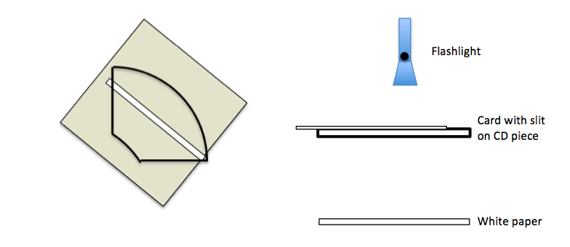
Figure 1 – Arrangement of the CD piece and slit, and projecting a rainbow on a piece of paper.

ACTIVITY 2 – MAKE A SPECTROSCOPE
When you looked through the grating you may have noticed that there were several rainbows, depending on how many light sources were in the room. Making a spectroscope will allow you to concentrate on one light source at a time. You will use the stripped CD piece from Activity 1 to separate the colors of the spectrum. To limit the amount of light that enters the front end you can use a slit cut in aluminum foil (requires adult help with a sharp knife) OR a piece of thin cardboard or dark construction paper with a hole poked in the center.
- Decorate the tube if you wish with markers, crayons or stickers.
- You don’t need to cut the piece of CD from Activity 1 into a circle to fit the end of the tube, but it looks a bit neater if you do. Trace around the tube onto the CD piece and carefully cut it out. Tape (or glue) the edges of the CD to one end of the tube. If you bought a diffraction grating, tape it to the end of the tube.
- To use a slit in aluminum foil: Wrap the piece of aluminum foil over the other end of the tube keeping it as smooth as possible. Poke a small round hole (just 2-3 mm) in the middle of the foil with the pencil, pen or needle.
To use construction paper (or thin cardboard): Trace the end of the tube on the paper and cut it out just a bit bigger than the tube so light doesn’t leak around the edges. Poke a hole about 2-3 mm in the center. Glue or tape the cardboard circle onto the other end of the tube.
Figure 2 shows diagrams of both methods.
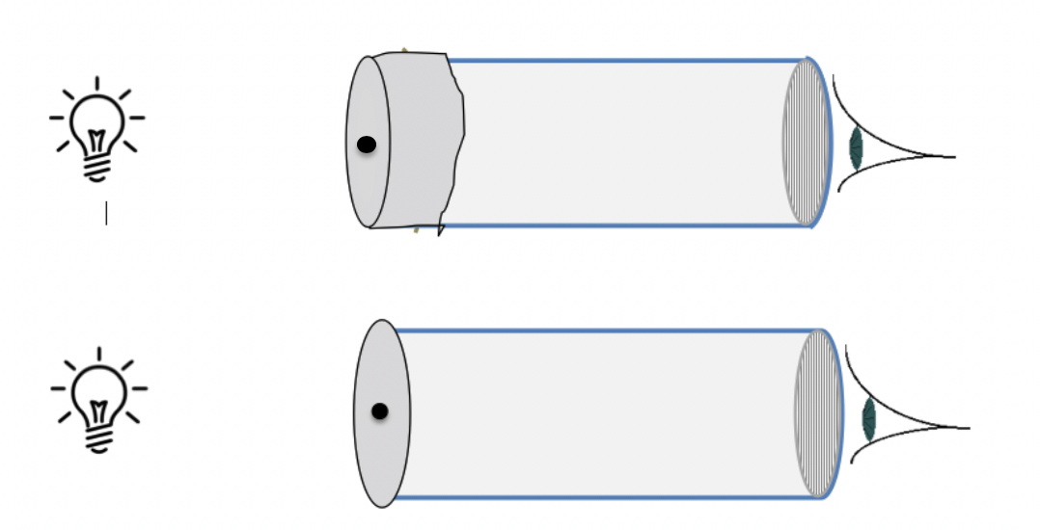

Figure 2 – The cardboard tube spectroscope. (Top) This diagram shows a aluminum foil on the front end. In(Bottom) This tube uses a circle cut from construction paper or cardboard instead of aluminum foil. You can see the cardboard circle is a bit bigger than the tube. These diagrams are not at all to scale!

- Your spectroscope is ready to use! Hold the CD end near your eye and point the slit or hole at a bright light. (See Figure 2.) Look into the tube through the CD. DO NOT LOOK AT THE SUN OR INTO A LASER.

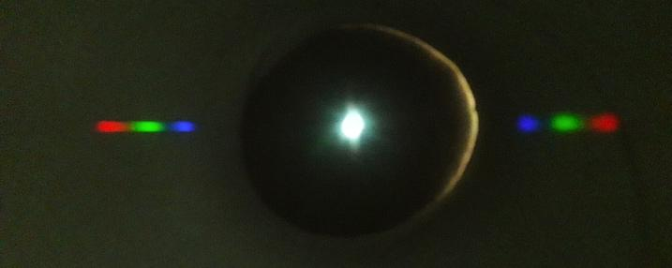

Figure 3 – This is what it looks like with construction paper. Aluminum foil causes reflections so the inside of the tube brighter. Some light is leaking around the edge of the cardboard on the right side. The photo was taken looking through the CD with the hole pointed at a white patch on a laptop screen. The laptop uses only three colors to make white!
ACTIVITY 3 – THE COLORS OF LIGHTS
To use your spectroscope, look through the grating while pointing the slit or hole at a light source. You might need to get close to the bulb but be very careful if it is hot. The spectrum will appear on the inside of the tube as shown in Figure 3. Try comparing these light sources (if you have them):
- Incandescent or LED, compact fluorescent “white” light bulbs, and white patch on a laptop screen. How are they different?
- Two lights of the same color like a red LED lamp and a red incandescent or fluorescent lamp
- Different colors on a laptop screen. How do you make yellow? Or purple?

Don’t forget to take a photo or video of your spectroscope or the spectra you observe
and post it on Twitter, LinkedIn or Facebook to help inspire others. You might need another person to hold the spectroscope while you line up the camera to take the photo. Make sure to
mention @OpticalSociety and use the hashtags #OpticsAtHome and #SeeTheLight.

A NOTE ON SAFETY
It’s important to remind children not to look at the sun or into a laser beam. They often don’t know why this is dangerous so it is a good opportunity to talk about safety. You can look at the solar (or laser) spectrum by looking at the light reflected from white paper, that is, put the white paper in the sunlight and look at the paper with the spectroscope. For a laser, turn down the room lights and shine the laser on a piece of white paper. Look at the laser reflection with the spectroscope. When we do this activity with a class we provide stickers for the spectroscope tubes stating: DO NOT LOOK AT THE SUN OR INTO A LASER!

RESOURCES
The Dumpster Optics Power Point slides for classroom use for this lesson are here: https://www.pblprojects.org/teaching-and-learning-optics-with-inexpensive-materials/
Here’s a video showing students making and using a spectroscope
https://youtu.be/YtZsDQLHdNc
More about why Isaac Newton included indigo in the seven spectral colors https://en.wikipedia.org/wiki/Indigo#Classification_as_a_spectral_color

